Production and Input Use under Market Frictions:
Firm Level Evidence for Ethiopia's Manufacturing Sector∗

Måns Söderbom^{a,}† and Hailegebriel Yigezu^{b},

a Department of Economics, University of Gothenburg, Sweden
email: mans.soderbom@handels.gu.se

b Department of Economics, Addis Ababa University, Ethiopia
email: hailaenani@gmail.com
hailegebriel.yirdaw@aau.edu.et

Production and Input Use under Market Frictions:
Firm Level Evidence for Ethiopia's Manufacturing Sector

Abstract
This paper examines whether Ethiopian manufacturing firms face constraints in using inputs, focusing on energy and raw materials. Using firm-level panel data from 2003–2016, we test for shadow costs that arise when input use is misaligned with its economic value. Our main approach embeds alignment restrictions, comparing cost shares to revenue elasticities within a dynamic production function estimated via nonlinear GMM. Firms generally under-use these inputs relative to their production value, with misalignment particularly pronounced for materials. Results are robust to an alternative test proposed by Shenoy (2021), which examines whether lagged inputs help predict current cost shares. While the data do not allow us to directly identify the specific sources of constraints, the findings provide evidence of economically significant shadow costs. The analysis also underscores the importance of careful instrument selection in applied production-function research.

Key Words: input elasticities, market frictions, shadow price, manufacturing firms, Ethiopia.
JEL Classification Code: D22; D24; L60; Q49

I. Introduction
Firms in low-income countries routinely operate in environments where input markets function poorly. In addition to financial and institutional barriers documented in the literature (De Mel et al., 2008; David et al., 2021), operational constraints, such as unreliable electricity, poor transport and logistics, thin supplier networks, and high procurement costs, affect not only prices but also firms’ ability to match input use to production needs (Amentie et al., 2016; Donga et al., 2016; McMillan & Zeufack, 2022; Verhoogen, 2023). A growing literature emphasizes how such frictions contribute to misallocation and hinder firm upgrading. While these distortions raise observed input prices, they may also generate unobservable shadow costs that do not appear in accounting data but nonetheless shape production decisions. This paper tests for the presence of shadow costs among Ethiopian manufacturing firms.
Our analysis is built around a simple economic intuition: in an efficient input market, the share of revenue spent on a flexible input should align closely with that input’s revenue elasticity. The cost share reflects the input intensity, while the elasticity captures the economic value of marginal use. When markets work well and inputs can be adjusted freely, these two objects should coincide. A systematic misalignment between cost shares and elasticities thus provides evidence for the existence of implicit costs associated with input market imperfections. This alignment logic underpins our empirical strategy and allows us to test for positive shadow costs in Ethiopian manufacturing.
Our focus is on energy and raw materials - inputs recognized as essential for firm performance in low-income countries. Unlike physical capital and (certain types of) labor, it is reasonable to assume that energy and materials are easily adjustable in efficient markets, making them ideal for assessing the impact of market inefficiencies on firm behavior. We test whether the average input elasticities for energy and materials equal their respective average cost shares, which provides a direct and economically interpretable test for the presence and strength of input constraints. Because energy and materials may be endogenously chosen by firms, we embed these alignment restrictions within a GMM estimation of the production function, which allows us to account for endogeneity while assessing whether the data are consistent with frictionless adjustment. This offers a way to assess the aggregate importance of input constraints using only observed revenues, inputs, and cost shares. In addition, we compare our results with a method proposed by Shenoy (2021) for testing input constraints, serving as a robustness check to see whether similar patterns emerge under an alternative framework.
The paper makes three main contributions. First, we provide new evidence on the misalignment between input cost shares and revenue elasticities for energy and materials in Ethiopian manufacturing. This misalignment indicates positive shadow costs, suggesting that firms face constraints in obtaining inputs and that these constraints contribute to inefficient production choices. Second, we contribute methodologically by embedding the alignment of cost shares and elasticities directly within the GMM estimation of the production function. This allows us to test for input constraints in a way that is economically interpretable and internally consistent. Third, we contribute to the applied production-function literature by showing how weak instruments can lead to misleading results unless robust testing methods are employed. We also highlight the particular challenges of addressing endogeneity in a translog specification, where the number of endogenous terms proliferates because many of the nonlinear terms involve the endogenous variables.
Finally, our findings have broader implications for firm productivity and efficiency. Misalignment between elasticities and cost shares signals that firms cannot easily obtain their desired levels of inputs, which likely reduces output efficiency and contributes to the misallocation of resources. While prior studies have examined input use in Ethiopian manufacturing, our focus on shadow costs and the direct testing of economic alignment provides a novel perspective, complementing existing analyses.
The rest of the paper is organized as follows. Section II presents the conceptual framework and empirical strategy. Section III describes the data. Section IV reports the main results. Section V concludes.

II. Conceptual Framework
We consider a model in which the revenue of firm $i$ at time $t$ depends on firm-level revenue productivity $A_{it}$ and a revenue production function $F\left(X_{it}\right)$, where $X_{it}$ is a vector of inputs, including energy and raw materials. The firm buys energy and raw materials, denoted respectively $E_{it}$, and $M_{it}$, at a fixed unit price, but subject to an upper bound ${\overset{‾}{Z}}_{it}^{e}$ for energy and ${\overset{‾}{Z}}_{it}^{m}$ for raw materials, which vary across firms and over time. The upper bounds ${\overset{‾}{Z}}_{it}^{e}$ and ${\overset{‾}{Z}}_{it}^{m}$ reflect distortions in the market for energy and raw materials respectively, and imply quantitative constraints on the energy and raw materials available to the firm at a given point in time.
Under the assumption that energy and raw materials are fully flexible inputs that are chosen optimally after the realization of $A_{it}$, the firm's energy and raw materials are set in accordance with the the first-order conditions
$$\begin{matrix} & A_{it}F_{E,it}=1+λ_{E,it} \\ & A_{it}F_{M,it}=1+λ_{M,it}\end{matrix}$$
where $F_{E,it}=\frac{∂F_{it}}{∂E_{it}},F_{M,it}=\frac{∂F_{it}}{∂M_{it}}$ are marginal revenue products, and $λ_{E,it}≥0$ and $λ_{M,it}≥0$ are the Lagrange multipliers associated with the constraints $E_{it}≤{\overset{‾}{Z}}_{it}^{e}$ and $M_{it}≤{\overset{‾}{Z}}_{it}^{m}$, respectively. The first-order conditions imply that the cost shares in total revenue can be written as
$CS_{E,it}=\frac{1}{1+λ_{E,it}}ξ_{E,it}$ (1a)
$CS_{M,it}=\frac{1}{1+λ_{M,it}}ξ_{M,it}$ (1b)
where $CS_{E,it}=(E_{it}/R_{it})$ and $CS_{M,it}=(M_{it}/R_{it})$ denote the cost shares, $ξ_{E,it}≡\frac{dR_{it}}{dE_{it}}\frac{E_{it}}{R_{it}}$ is the elasticity of revenue with respect to energy and $ξ_{M,it}≡\frac{dR_{it}}{dM_{it}}\frac{M_{it}}{R_{it}}$ is the elasticity of revenue with respect to raw materials. If the firm is unconstrained, the input elasticity aligns with the cost share, $CS_{E,it}=ξ_{E,it}, CS_{M,it}=ξ_{M,it}$, while if the firm is constrained the Lagrange multiplier drives a wedge between the input elasticity and the associated cost share.
The theory thus predicts perfect alignment between elasticity and cost share for unconstrained firms, while for constrained firms the cost share will be lower than the elasticity. This result is the basis for our empirical testing strategy. Testing for alignment for each firm-year is not meaningful since firm-level estimates are noisy and affected by idiosyncratic shocks. Instead, we focus on averages across firms. When a larger share of firms face input constraints, and when those constraints are more severe, the average cost share declines, creating a greater mismatch between the average elasticity and the average cost share. Comparing these averages thus provides insights into the aggregate economic importance of constraints. We therefore test the null hypothesis that the average log elasticities for energy and materials are equal to their respective average log cost shares:
$H_{0}:log⁡\left({\overset{‾}{ξ}}_{E}\right)=\overline{log⁡CS_{E}}$ and $log⁡\left({\overset{‾}{ξ}}_{M}\right)=\overline{log⁡CS_{M}}$ (2)
against the alternative that the null hypothesis is not true.
Input elasticities
We analyze the input elasticities $ξ_{E,it}$ and $ξ_{M,it}$ using a production function approach. We consider a four-factor revenue production function, expressed in logarithmic form as
- $r_{it}=log⁡F\left(L_{it},K_{it},E_{it},M_{it}\right)+ω_{it}+ε_{it}$ (3)
where $r_{it}=log⁡R_{it}$ is log revenue, $ω_{it}=log⁡A_{it}$ is log TFPR (Total Factor Productivity of Revenue), $L_{it}$ is labor, $K_{it}$ is physical capital (e.g. machinery and equipment), and $ε_{it}$ is a measurement error in output. We assume that $ω_{it}$ follows an AR(1) process,
$ω_{it}=ρω_{i,t-1}+η_{it}$
- where $ρ$ is a persistence parameter and $η_{it}$ is a productivity innovation that is independent across time and firms. Quasi-differencing eq. (3) yields
- $r_{it}= ρr_{i,t-1}+log⁡F\left(L_{it},K_{it},E_{it},M_{it}\right)-ρlog⁡F\left(L_{i,t-1},K_{i,t-1},E_{i,t-1},M_{i,t-1}\right)+v_{it}$ (4)
where $v_{it}=η_{it}+ε_{it}-ρε_{i,t-1}$ is the equation error term.
We assume a translog production function:
$\begin{matrix}\log{F\left(L_{it},K_{it},E_{it},M_{it}\right)} & =α_{l}l_{it}+α_{k}k_{it}+α_{e}e_{it}+α_{m}m_{it}+α_{ll}l_{it}^{2}+α_{kk}k_{it}^{2}+ \\ & α_{ee}e_{it}^{2}+α_{mm}m_{it}^{2}+α_{lk}\left(l_{it}k_{it}\right)+α_{le}\left(l_{it}e_{it}\right)+ \\ & α_{lm}\left(l_{it}m_{it}\right)+α_{ke}\left(k_{it}e_{it}\right)+α_{km}\left(k_{it}m_{it}\right)+α_{em}\left(e_{it}m_{it}\right) \end{matrix}$ (5)
where lower case letters denote inputs in logs. In the empirical analysis below, the log inputs are expressed as deviations from their sample means, so that the sample-average elasticities for energy and materials, denoted by ${\overset{ˉ}{ξ}}_{E}$and ${\overset{ˉ}{ξ}}_{M}$, are equal to $α_{e}$and $α_{m}$, respectively. Using the translog specification in (4) yields our benchmark empirical specification:
$r_{it}= ρr_{i,t-1}+α_{l}{(l}_{it}-ρl_{i,t-1})+α_{k}{(k}_{it}-ρk_{i,t-1})+α_{e}(e_{it}-ρe_{i,t-1})+α_{m}(m_{it}-ρm_{i,t-1})+α_{ll}(l_{it}^{2}-ρl_{i,t-1}^{2})+α_{kk}(k_{it}^{2}-ρk_{i,t-1}^{2})+α_{ee}(e_{it}^{2}-ρe_{i,t-1}^{2})+α_{mm}(m_{it}^{2}-ρm_{i,t-1}^{2})+α_{lk}(l_{it}k_{it}-ρl_{i,t-1}k_{i,t-1})+α_{le}(l_{it}e_{it}-ρl_{i,t-1}e_{i,t-1})+α_{lm}(l_{it}m_{it}-ρl_{i,t-1}m_{i,t-1})+α_{ke}(k_{it}e_{it}-ρk_{i,t-1}e_{i,t-1})+α_{km}(k_{it}m_{it}-ρk_{i,t-1}m_{i,t-1})+α_{em}(e_{it}m_{it}-ρe_{i,t-1}m_{i,t-1})+v_{it}$ .
(6)
Estimation
We estimate the parameters $ρ$, $α_{l},α_{k},…,α_{em}$ using nonlinear GMM, and moment conditions of the form
$E\left(z_{it}v_{it}\right)=0$ (7)
where $z_{it}$ is a vector of instruments. Labor and capital are assumed predetermined, which implies that $l_{it}$, $k_{it}$, $l_{it}^{2}, k_{it}^{2}$and $l_{it}k_{it},$as well as their lags, are orthogonal to the error term $v_{it}$. These variables can thus serve as instruments. In contrast, energy ($e_{it}$), materials ($m_{it}),$and all interaction and squared variables that contain $e_{it} or m_{it},$are endogenous. Contemporaneous $e_{it}$and $m_{it}$, and any nonlinear terms containing these variables, cannot be used as instruments. However, lags of $e_{it}$and $m_{it}$, and nonlinear terms containing these lags, can be used as instruments, since (by assumption) the productivity innovation in $v_{it}$is independent across time.
Testing for alignment of elasticities and cost shares
To formally test for the presence of shadow costs, we embed the alignment of cost shares and revenue elasticities directly within the production function estimation, following the economic intuition that, in frictionless markets, cost shares should match the corresponding elasticities. To do this, we first decompose the log of each cost share into its population mean and an idiosyncratic component:
$\log{CS_{E,it}}=\overline{\log{CS_{E}}}+ϑ_{it}^{E}$
$\log{CS_{M,it}}=\overline{\log{CS_{M}}}+ϑ_{it}^{M}$ .
where $\overline{\log{CS_{E}}}$ and $\overline{\log{CS_{M}}}$denote population means, while $ϑ_{it}^{E}$and $ϑ_{it}^{M}$ represent the zero-mean deviations from these means. Adding ${E(ϑ}_{it}^{E})=0$ and ${E(ϑ}_{it}^{M})=0$ to the set of moment conditions in (7), it is straightforward to test the restrictions $log⁡(α_{e})=\overline{\log{CS_{E}}}$ and $\log\left(α_{m}\right)=\overline{\log{CS_{M}}}$.
Testing under weak instruments
Weak correlation between lagged and current inputs can cause a weak instruments problem in estimating the production function. In general, if instruments are weak, standard (large-sample) GMM point estimates and hypothesis tests are unreliable (see e.g. Stock et al. (2002)). We assume that the parameters associated with capital, labor, their squared terms, and the capital-labor interaction term, are strongly identified. In contrast, since energy and materials are endogenous, which prevents the use of their contemporaneous values as instruments, we must recognize that all parameters in (6) that are associated with energy or materials may be weakly identified. There are thus nine parameters in (6) for which we assume identification to be weak: $α_{e},α_{m},α_{ee},α_{mm},α_{em},α_{ke},α_{le},α_{km}$and $α_{le}.$ To test for alignment of elasticities and cost shares, we use the weak instrument robust "S-test" proposed by Stock & Wright (2000).
The Shenoy (2021) test for input market frictions
As a robustness check, we also consider the test proposed by Shenoy (2021) for detecting input market frictions. Like our approach, Shenoy’s test is based on the first-order condition for flexible inputs and examines whether firms behave as if they are unconstrained in their access to these inputs. While the theoretical foundation is similar, the implementation differs, making it useful to compare the two methods and assess whether they yield consistent conclusions about input constraints.
We can relate to Shenoy's analysis by revisiting the first-order conditions (1a)-(1b) which link cost shares to elasticities. Taking logs of the first-order condition for materials (1b) we obtain
$log⁡\left(CS_{M,it}\right)=log⁡\left(ξ_{M,it}\right)-Λ_{M,it}$ (8)
where $Λ_{M,it}=ln⁡\left(1+λ_{M,it}\right)$. The elasticity $ξ_{M,it}$ can be expressed in terms of contemporaneous inputs in the production function inputs. For the translog specification,
$ξ_{M,it}=α_{m}+2α_{mm}m_{it}+α_{lm}l_{it}+α_{km}k_{it}+α_{em}e_{it}$.
Under the null hypothesis of no constraints, $Λ_{M,it}=0$ so only contemporaneous inputs should matter for the cost share:
$\log\left(CS_{M,it}\right)=\log{(α_{m}+2α_{mm}m_{it}+α_{lm}l_{it}+α_{km}k_{it}+α_{em}e_{it})}$.
Under the alternative, additional variables that proxying $Λ_{M,it}$ have explanatory power. Shenoy proposed using lagged inputs $r_{M,it}$ as proxies for $Λ_{M,it}$, and testing whether these lags significantly predict the cost share, conditional on the contemporaneous values. In Section IV we present results from this type of test, which serves as a robustness check for our alignment-based approach.

II. Data and Descriptive Statistics
- Data
This study uses unbalanced firm-level panel data for the period between 2003 and 2016, constructed from annual surveys of large and medium scale manufacturing firms in Ethiopia. The underlying surveys, known as the Large and Medium Scale Manufacturing Industries (LMSMI) surveys, have been conducted by the Central Statistical Agency (CSA) of Ethiopia. The entire dataset consists of 8,698 firms and 24,132 firm-year observations. The data set covers all manufacturing establishments in Ethiopia that employ at least ten workers and use power-driven machinery for production. It provides a comprehensive and detailed source of information on various aspects of manufacturing firm activity, including the gross value of output, sales value of output, fixed capital value, employee wage and salary expenditures, raw material costs, fuel and energy costs, ownership status, year of establishment, location, and other relevant details. The full sample covers 15 manufacturing sectors. In the empirical analysis we present results for the pooled sample, with additional results by industry group provided in Online Appendix B.
The key variables in our empirical analysis are output, capital, labor, energy, and raw materials. Output is measured by the sales value of all products produced by the firm in a given year. Labor is measured by the total wages and salaries paid to both permanent and temporary workers during the production period. Capital is represented by the value of assets with a productive life of one year or more, calculated as the net book value at the beginning of the year, plus new capital expenditures, minus the value of sold or disposed machinery and equipment, and depreciation within the reference period. Raw material costs are measured ast the expenditure on materials sourced domestically or imported. Energy expenditures include costs for fuel and lubrication, wood and charcoal, and electricity. Further details on variable constriction are provided in Online Appendix A. Nominal values have been adjusted using deflators from the World Bank database, with 2010 as the base year. Output is deflated by the sectoral GDP deflator, capital by the fixed capital formation deflator, and energy, wages, and materials by the Consumer Price Index (CPI). We clean the data by removing the lower and upper 2 percent of outliers, and by excluding non-positive values for the main variables used in our empirical analysis.
- Descriptive statistics
- Table 1 presents descriptive statistics for the main variables used in our empirical analysis. Additional results for separate industry groups are shown in the Online Appendix. Our sample includes 2,062 firms, corresponding to 7,651 firm-year observations. All variables are measured annually, with monetary values expressed in Ethiopian birr, and deflated using the deflators described above. Average expenditure on energy inputs is notably lower compared to non-energy inputs, such as labor, capital, and raw materials. Raw materials constitute the largest share of inputs in production. The average log energy cost share is -4.23, which corresponds to a share of 0.015. The average log materials cost share is -0.73, corresponding to a share of 0.48. Under the null hypothesis that output elasticities equal cost shares, we would expect the estimated average elasticities for energy and materials to be close to these values.

IV. Empirical Results
Table 2 shows nonlinear two-step GMM estimates of the average elasticities, for the whole sample. In these specifications, raw materials and energy are treated as endogenous inputs, while labor and capital are assumed predetermined. The instruments are based on output dated t-2, labor and capital dated $t$ and t-1, and energy and materials dated t-1. A full set of year dummies is added to all specifications.
The full translog model includes levels, squares and interactions of the four inputs (in logs; see eq. (7)). Because all nonlinear terms involving either energy or raw materials are econometrically endogenous, this specification contains a total of nine endogenous variables. Natural candidates for the instrument set include lags of levels, squares and interactions, as well as contemporaneous values for variables that are assumed predetermined. Identification can be challenging because each endogenous term (levels, squares and interactions) requires instruments that provide sufficient independent variation. Given that the full translog specification contains many endogenous terms, the instrument set may not contain enough independent variation for identification to be strong. Under weak identification, point estimates are biased and conventional t-tests can be misleading. To assess instrument strength we report Kleibergen-Paap rk statistics, computed using the approach by Shenoy (2021). The null distribution underlying this approach is that the instruments are completely uninformative about all endogenous variables. Therefore, non-rejection of the null strongly suggests a weak instrument problem (but rejection does not necessarily imply strong identification). Throughout, we use methods that are robust to weak instruments for testing our key null hypothesis on alignment.
Results for the full translog specification are shown in Table 2, col. [1]. The average elasticity for raw materials is estimated at 0.80, while the average estimated energy elasticity is 0.06. Both estimates are considerably higher than their corresponding cost shares (exp(-4.23) = 0.015 and exp(-0.73)=0.48, respectively), suggesting that elasticities and cost shares do not align. The estimated average labor elasticity is 0.13 while the capital elasticity is 0.02.
The standard errors reported in Table 2 are the conventional two-step GMM standard errors, which provide an appropriate basis for hypothesis under strong identification but not under weak identification. Taken at face value, the results suggest that the average elasticities for labor and materials are significantly different from zero, while the elasticities for capital and energy are not statistically significant. The Kleibergen-Paap rk statistic is 0.22, thus considerably lower than the “rule of thumb” which is 10. Using the bootstrapping procedure proposed by Shenoy (2021) we can reject the null hypothesis that all instruments are completely uninformative for all endogenous variables at the 10% level of significance but not at the 5% level. We consider identification to weak in this case, hence any conclusions regarding statistical significance based on conventional testing methods should be interpreted with caution.
Results for weak instrument robust tests for the alignment of cost shares and elasticities are shown in Table 3. Column [1] shows the results for the full translog model, with the null hypothesis given by eq. (2) above. In total, there are 37 instruments, 23 strongly identified parameters and nine weakly identified parameters. This implies that S-statistic follows a chi-squared distribution with 37-23 = 14 degrees of freedom. The S-value is 3.2, which implies a p-value close to 1.0. Hence we do not reject the null hypothesis of alignment in this case.
We now consider a reduced version of the translog specification in which all the nonlinear terms associated with either energy or materials are suppressed. In other words, the endogenous variables energy and materials now enter the production function only linearly. This reduces the number of endogenous regressors from nine to two, which could strengthen identification considerably. When tested, we find that the excluded terms are jointly insignificant in the full translog specification (S-test; p-value = 0.27), which provides some justification for excluding them. We also exclude the corresponding instruments, i.e. the lags of the nonlinear endogenous terms. Results for this “intermediate” specification are shown in Table 2 col. [2]. The estimated average elasticities are similar to those obtained from the full translog specification. A noteworthy difference is that the Kleibergen-Paap rk statistic is now considerably higher, and we can reject the null hypothesis that all the instruments are uninformative at the 5% significance level. This suggests that weak instruments pose less of a problem for this specification than for the full translog.
Table 3, column [2], reports the results of the S-test for alignment between the average elasticities and average cost shares of energy and raw materials. Because this intermediate specification includes fewer parameters than the full translog model, we can rely on a smaller set of instruments, reducing the degrees of freedom to 7. The S-value is 33.0, so we can reject the null hypothesis of alignment at the 1% significance level. Further analysis reveals that this rejection is driven primarily by the discrepancy between the elasticity and the cost share for raw materials. These results provide strong evidence against the null hypothesis: firms use materials less intensively than the production technology, as reflected in the elasticity, would warrant.
Finally, we consider the results from a simple Cobb-Douglas specification, presented in Table 3 col. [3]. Compared to the intermediate specification in col. [2], the Cobb-Douglas specification excludes capital and labor squared and their interaction, and the corresponding instruments. The estimated elasticities are broadly similar to those obtained from the previous specifications. The S-test for alignment, reported in Table 3, column [3], shows that, as with the “intermediate” specification, the null hypothesis can be rejected at the 1% significance level. Whether one should prefer the intermediate specification or the Cobb-Douglas specification is somewhat moot, given that the results are very similar. When tested, the squared terms for capital and labor, along with their interaction, are highly significant. On this statistical basis, we consider the intermediate specification to be the preferred model.
The Shenoy (2021) test for input market frictions
To implement the Shenoy (2021) test, we use nonlinear least squares to estimate cost-share regressions of the form
- $log⁡\left(\frac{X_{it}}{R_{it}}\right)=ln⁡\left(ξ_{X,it}\right)-r_{X,it}φ_{X}+U_{X,it}, X=(E,M)$ (9)
where $U_{X,it}$ is an error term. We approximate the elasticity $ξ_{X,it}$ by a polynomial in our four (log) inputs, and test for the joint significance of lagged variables that are contained in the vector $r_{X,it}$. Under the null hypothesis of no constraints, these lags have no explanatory power. Significant coefficients on the lagged inputs therefore indicate a rejection of the null, suggesting the presence of input constraints.
In Table 4 we present the results of the Shenoy (2021) test for the joint significance of lagged capital, labor, materials and energy. We can strongly reject the null hypothesis of no constraints for both energy and raw materials. These findings are consistent with our main alignment-based analysis: both methods indicate that firms are constrained in their access to inputs. While the approaches differ in implementation, the two methods converge on the same conclusion, providing evidence of input market frictions in Ethiopian manufacturing.
The two tests also differ in the types of constraints they are most likely to detect. The Shenoy test is more likely to reject the null when constraints generate a dynamic relationship between cost shares and inputs, such as in the presence of significant input adjustment costs, whereas the alignment test may not capture such dynamics. Conversely, the Shenoy test may fail to detect constraints that are non-persistent, while the alignment test is specifically designed to capture these. In principle, combining both approaches could provide a more comprehensive test for input constraints, although we do not pursue such a unified approach here. This highlights a key complement of the alignment-based method: it tests for economically meaningful misalignment between cost shares and marginal product-based elasticities, providing an indicator of input market frictions that may not involve the dynamic constraints captured by the Shenoy test.

V. Summary and Conclusions
This paper provides evidence that Ethiopian manufacturing firms face significant constraints in their access to key inputs, particularly raw materials. Using firm-level panel data from 2003–2016, we test for the presence of shadow costs that arise when input use is misaligned with its economic value. Our main approach embeds alignment restrictions on the relationship between cost shares and revenue elasticities within a dynamic revenue production function estimated via nonlinear GMM. This allows us to account for the potential endogeneity of energy and materials while directly testing whether firms behave as if they can adjust these inputs freely.
Our results show that the estimated elasticities for both energy and raw materials are generally higher than the corresponding cost shares, indicating that firms under-use these inputs relative to their production value. The misalignment is particularly pronounced for materials, suggesting stronger constraints in the markets for such inputs. We complement the alignment-based approach with the Shenoy (2021) test, which examines whether lagged inputs help predict current cost shares. While the two methods differ in focus, they lead to the same conclusion: firms face input constraints. We highlight a key contribution of the alignment-based method: it provides a direct, economically meaningful indicator of input market frictions that may not be detected by methods relying on dynamic relationships.
Methodologically, our analysis underscores the importance of accounting for weak instruments. In the full translog specification, the large number of endogenous terms makes identification challenging. Reducing the number of endogenous regressors improves instrument strength, improving the power of our tests. This finding may be of interest to applied researchers using production functions, as it illustrates how careful attention to instrument selection and model specification can affect inference.
Overall, our findings indicate that input market frictions have substantial effects on production decisions in Ethiopian manufacturing. Firms under-utilize raw materials relative to their marginal value, implying significant shadow costs. At the same time, it is important to acknowledge that our data do not allow us to directly identify the specific sources of these constraints, such as electricity shortages, procurement costs, or supplier network limitations. While our results reveal the presence and economic significance of shadow costs, understanding the precise mechanisms behind these frictions remains an important avenue for future research. Addressing the underlying constraints, once identified, could enhance production efficiency and output in the sector.

Table 1. Summary statistics
 | Mean | Std dev
log Labor | 12.5 | 1.69
log Capital | 13.65 | 2.57
log Energy | 10.77 | 2.07
log Raw materials | 14.28 | 2.02
log Output value | 15.01 | 1.87
log Energy cost share | -4.23 | 1.53
log Materials cost share | -0.73 | 0.86
Number of firms | 2062
Number of observations | 7651
Note: All variables are expressed in logarithmic form. In levels all variables are measured in real monetary terms. The cost share of energy for sectors is calculated as the log of energy to output. The cost share of raw materials for sectors is calculated as the log of raw materials to output. The table shows mean values and standard deviations. For all regressions in this paper, log inputs are mean-centered. Source: Own computations using CSA data.

Table 2. Two-step GMM estimates of production function parameters
 | [1]  Translog | [2]  Intermediate | [3]  Cobb-Douglas
Average elasticities:
Labor $(α_{l})$ | 0.128 | 0.145 | 0.148
 | (0.041) | (0.015) | (0.016)
Capital $(α_{k})$ | 0.018 | 0.020 | 0.008
 | (0.020) | (0.020) | (0.009)
Energy $(α_{e})$ | 0.058 | 0.003 | 0.037
 | (0.090) | (0.044) | (0.039)
Raw material $(α_{m})$ | 0.798 | 0.822 | 0.797
 | (0.071) | (0.037) | (0.036)
Average log cost shares
log Energy cost share: $\overline{\log{CS_{E}}}$ | -4.232 | -4.232 | -4.232
 | (0.029) | (0.029) | (0.029)
log Material cost share: $\overline{\log{CS_{M}}}$ | -0.729 | -0.729 | -0.729
 | (0.013) | (0.013) | (0.013)
AR(1) coefficient:
$$ρ$$ | 0.409 | 0.3437 | 0.328
 | (0.037) | (0.044) | (0.047)
J-statistic | 1.99 | 6.86 | 2.68
J p-value | 0.85 | 0.23 | 0.26
KP Wald F-statistic (weak IV) | 0.220* | 14.34** | 25.62**
Number of parameters | 32 | 25 | 22
Number of moments | 37 | 30 | 24
Number of firms | 2,062 | 2,062 | 2,062
Number of observations | 7,651 | 7,651 | 7,651
Note: All variables are expressed in logarithmic form. The dependent variable is the sales value of produced output. Labor and capital are predetermined whereas raw materials and energy are endogenous. Robust standard errors in parentheses. KP refers to Kleibergen & Paap (2006), with * and ** indicating statistical significance at $10\%$ and $5\%$ levels respectively. All monetary variables are deflated using price indices, as described in the main text. All inputs are mean-centered in estimation.

Table 3. Alignment of Elasticities and Cost Shares: Weak Instrument Robust Tests
 | [1]  Translog | [2]  Intermediate | [3]  Cobb-Douglas
H₀: $log⁡(α_{e})=\overline{\log{CS_{E}}}$,
$$log⁡(α_{m})=\overline{\log{CS_{M}}}$$
S statistic | 3.24 | 33.02 | 21.92
Number of instruments | 37 | 30 | 24
Number of strongly identified parameters | 23 | 23 | 20
Df | 14 | 7 | 4
p-value | 0.99 | 0.00 | 0.00
Note: This table reports weak-instrument-robust S-tests (Stock and Wright, 2000). The S statistic is evaluated under the null hypothesis and compared to a Chi-square distribution with degrees of freedom equal to the number of instruments minus the number of strongly identified nuisance parameters.

Table 4: Tests for the joint significance of the lagged inputs
 | Instruments | [2] F statistic | [3] p-value
(a):m(raw materials) | lagged inputs: $k_{t_{-}1},l_{t-1},m_{t-1},e_{t-1}$ | $$F(4,2061)=22.06$$ | 0.00
(b):e(energy) | lagged inputs: $k_{t_{-}1},l_{t-1},m_{t-1},e_{t-1}$ | $$F(4,2061)=55.43$$ | 0.00
Note: This table reports Shenoy (2021) tests for the joint significance of the lagged inputs. All variables are expressed in logarithmic form.

- Refeences
Abebe, G., McMillan, M. S., & Serafinelli, M. (2018). Foreign Direct Investment and Knowledge Diffusion in Poor Locations (Working Paper Series, Issue 24461). https://doi.org/10.3386/w24461
Abegaz, M. T. (2013). Total Factor Productivity and Technical Efficiency in the Ethiopian Manufacturing Sector.
Abreha, K. G. (2019). Importing and firm productivity in ethiopian manufacturing. The World Bank Economic Review, 33(3), 772–792.
Ackerberg, D. A., Caves, K., & Frazer, G. (2015). Identification properties of recent production function estimators. Econometrica, 83(6), 2411–2451.
Amentie, C., Negash, E., & Kumera, L. (2016). Barriers to growth of medium and small enterprises in developing country: Case study Ethiopia. Journal of Entrepreneurship & Organisation Management, 5(3). https://www.omicsonline.org/open-access/barriers-to-growth-of-medium-and-small-enterprises-in-developing-country-case-study-ethiopia-2169-026X-1000190.pdf
Anderson, W. (2017). Factors affecting small and medium enterprises (SMEs) start-up and growth in Tanzania. The Pan-African Journal of Business Management, 1(1), 1–26. https://pajbm.out.ac.tz/PAJBM
Ascari, G., Haque, Q., Magnusson, L. M., & Mavroeidis, S. (2024). Empirical evidence on the Euler equation for investment in the US. Journal of Applied Econometrics (Chichester, England), 39(4), 543–563.
Bigsten, A., & Gebreeyesus, M. (2009). Firm productivity and exports: Evidence from Ethiopian manufacturing. The Journal of Development Studies, 45(10), 1594–1614.
Bigsten, A., Gebreeyesus, M., & Söderbom, M. (2016). Tariffs and firm performance in Ethiopia. The Journal of Development Studies, 52(7), 986–1001.
Caves, D. W., Christensen, L. R., & Diewert, W. E. (1982). The economic theory of index numbers and the measurement of input, output, and productivity. Econometrica: Journal of the Econometric Society, 1393–1414.
De Loecker, J., Eeckhout, J., & Unger, G. (2020). The rise of market power and the macroeconomic implications. The Quarterly Journal of Economics, 135(2), 561–644.
de Roux, N., Eslava, M., Franco, S., & Verhoogen, E. (2024). Estimating Production Functions in Differentiated-Product Industries with Quantity Information and External Instruments (Working Paper Series, Issue 28323). https://doi.org/10.3386/w28323
Diao, X., Ellis, M., McMillan, M. S., & Rodrik, D. (2021). Africa’s manufacturing puzzle: Evidence from Tanzanian and Ethiopian firms.
Donga, G., Ngirande, H., & Shumba, K. (2016). Perceived barrier to the development of small, medium and microenterprises: a case study of Thulamela Municipality in the Limpopo Province. Problems and Perspectives in Management, 14(4), 61–66. https://businessperspectives.org/images/pdf/free/8023/PPM_2016_04_Donga.pdf
Fowowe, B. (2017). Access to finance and firm performance: Evidence from African countries. Review of Development Finance, 7, 6–17. https://www.sciencedirect.com/science/article/pii/S1879933717300106
Gandhi, A., Navarro, S., & Rivers, D. A. (2020). On the identification of gross output production functions. Journal of Political Economy, 128(8), 2973–3016.
Hailu, K. B., & Tanaka, M. (2015). A “true” random effects stochastic frontier analysis for technical efficiency and heterogeneity: Evidence from manufacturing firms in Ethiopia. Economic Modelling, 50, 179–192.
Hansen, L. P., Heaton, J., & Yaron, A. (1996). Finite-sample properties of some alternative GMM estimators. Journal of Business & Economic Statistics, 14(3), 262–280.
Hassen, S., Gebrehiwot, T., & Arega, T. (2018). Determinants of enterprises use of energy efficient technologies: Evidence from urban Ethiopia. Energy Policy, 119, 388–395.
Kebede, S. G., & Heshmati, A. (2020). Energy use and labor productivity in Ethiopia: the case of the manufacturing industry. Energies, 13(11), 2714.
Kleibergen, F., & Paap, R. (2006). Generalized reduced rank tests using the singular value decomposition. Journal of Econometrics, 133(1), 97–126.
Kumar, R. (2017). Targeted SME Financing and Employment Effects: What Do We Know and What Can We Do Differently? http://documents.worldbank.org/curated/en/577091496733563036/Targeted-SME-financing-and-employment-effects-what-do-we-know-and-what-can-we-do-differently
Levinsohn, J., & Petrin, A. (2003). Estimating production functions using inputs to control for unobservables. The Review of Economic Studies, 70(2), 317–341.
Loecker, J. De, & Warzynski, F. (2012). Markups and firm-level export status. American Economic Review, 102(6), 2437–2471.
Mavroeidis, S., Plagborg-Møller, M., & Stock, J. H. (2014). Empirical Evidence on Inflation Expectations in the New Keynesian Phillips Curve. Journal of Economic Literature, 52(1), 124–188.
McMillan, M., & Zeufack, A. (2022). Labor productivity growth and industrialization in Africa. Journal of Economic Perspectives, 36(1), 3–32.
Ndiaye, N., Razak, L. A., Nagayey, R., & Ng, A. (2018). Demystifying small and medium enterprises’ (SMEs) performance in emerging and developing economies. Borsa Istanbul Review. https://www.sciencedirect.com/science/article/pii/S2214845018300280
Olafsen, E., & Cook, P. A. (2016). Growth entrepreneurship in developing countries: a preliminary literature review. https://www.infodev.org/infodev-files/growth_entrepreneurship_in_developing_countries_-_a_preliminary_literature_review_-_february_2016_-_infodev.pdf
Olley, G. S., & Pakes, A. (1996). The Dynamics of Productivity in the Telecommunications Equipment Industry. Econometrica, 64(6), 1263–1297.
Onubedo, G., & Yusuf, K. M. (2018). Finance and Firm Productivity in Africa: Background Study from World Bank Enterprise Data Survey. https://www.africaportal.org/publications/finance-and-firm-productivity-africa-background-study-world-bank-enterprise-survey-data/
Quartey, P., Turkson, E., Abor, J. Y., & Ma, A. (2017). Financing the growth of SMEs In Africa: What are the constraints to SME financing within ECOWAS? Review of Development Finance, 7(1), 18–28. https://www.sciencedirect.com/science/article/pii/S1879933717300362
Shenoy, A. (2021). Estimating the production function under input market frictions. Review of Economics and Statistics, 103(4), 666–679.
Siba, E., Söderbom, M., Bigsten, A., & Gebreeyesus, M. (2012). Enterprise agglomeration, output prices, and physical productivity: Firm-level evidence from Ethiopia.
Siba, E., Söderbom, M., Bigsten, A., & Gebreeyesus, M. (2020). The relationship among enterprise clustering, prices, and productivity in Ethiopia’s manufacturing sector. Review of Development Economics, 24(3), 831–854.
Stock, J. H., & Wright, J. H. (2000). GMM with weak identification. Econometrica, 68(5), 1055–1096.
Stock, J. H., Wright, J. H., & Yogo, M. (2002). A survey of weak instruments and weak identification in generalized method of moments. Journal of Business & Economic Statistics, 20(4), 518–529.
Tekleselassie, T. G., Berhe, K., Getahun, T. D., Abebe, G., & Ageba, G. (2018). Productivity Determinants in the Manufacturing Sector in Ethiopia: Evidence from the Textile and Garment Industries. Ethiopian Development Research Institute (EDRI).
Verhoogen, E. (2023). Firm-level upgrading in developing countries. Journal of Economic Literature, 61(4), 1410–1464.
Wang, Y. (2016). What are the biggest obstacles to growth of SMEs in developing countries? – An empirical evidence. Borsa Istanbul Review, 16(3), 167–176. https://www.sciencedirect.com/science/article/pii/S2214845016300539

Online Appendix
Appendix A: Information about the data set and variable construction
The data set
We use two firm level panel data sets that were merged by a team of researchers based at the then Ethiopian Development Research Institute (EDRI) and Oxford University. To fix the establishment identification problem associated with a change in the establishment’s identification number made by Central Statistical Agency(CSA) in 2011, the teams relied on firm International Standard Industry Classification(ISIC) code, establishment number, taxpayer identification number, phone number and establishment name. The first firm level panel data set spans 1996-2013 (Western calendar). In this data set there are 6,321 firms with 21,288 firm-years observations. The second firm level panel data set is obtained from International Growth Center (IGC) in Ethiopia and spans the period 2012-2017 (Western calendar). This data set has 8,135 firms and 14,896 firm year observations. We identified firms that exist in both data sets and merge these two datasets using the year 2013 as linking year. We keep the datasets from the year 2000 to 2016 with total of 9,780 firms with 26,488 firm year observations. We trimmed the upper and lower 2% to deal with outliers and dropped 2,337 observations with non-positive values (i.e. 1,263 on energy variable,694 on labor and 380 on capital). Thus, we have 8,698 firms with 24,132 firm year observations. In our estimation sample there are 2,062 firms and 7,651 firm-year observations.
Construction of variables
- Output is measured by the sales value of output produced by the firm in a given year
2. Capital: We employ the perpetual inventory method to construct physical capital at the end of the year using: total book value at the beginning of the year; total investment on capital purchase and repair; capital sold and disposed; and depreciation
- Labor: The cost of labor is calculated as: Wages and Salaries + (Commissions, Bonuses, Professional, and Hardship Allowances) + (Supplements to Wages and Salaries of Employees i.e. Actual cost of the establishment on food, lodging, medical and other benefits + Establishments contribution on behalf of employees to pension, life and casualty)
- Energy: To get expenditure on energy we combine expenditures on electricity, fuel and lubricating oil, and charcoal and wood.
- Raw material: We computed the value of raw material summing up the value of local raw material and imported raw material.
- Note: All variables are deflated using price indices, as described in the main text.

Appendix B: Results for Industry groups
Table B.1
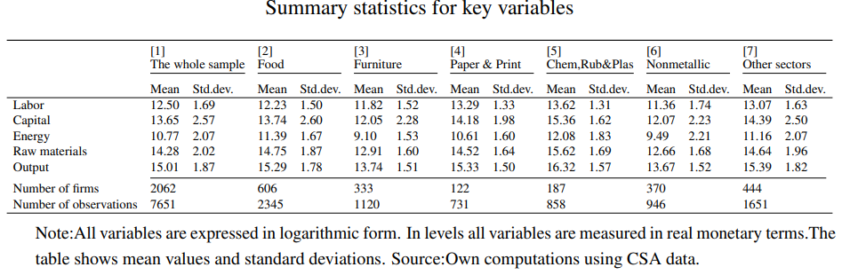
Table B.2
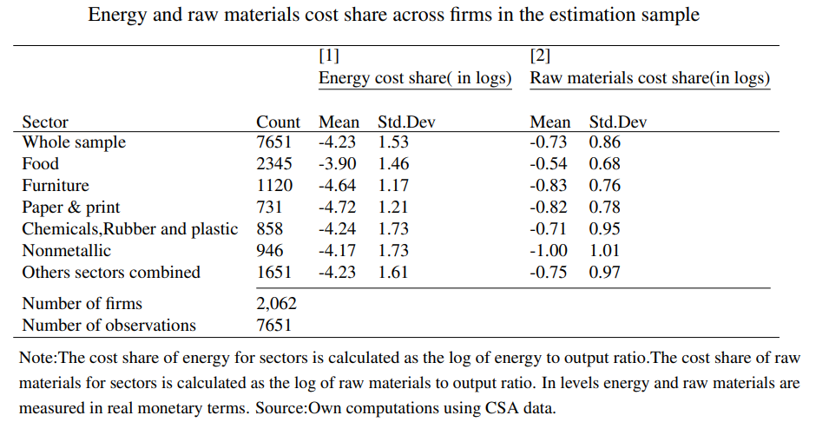

Table B.3
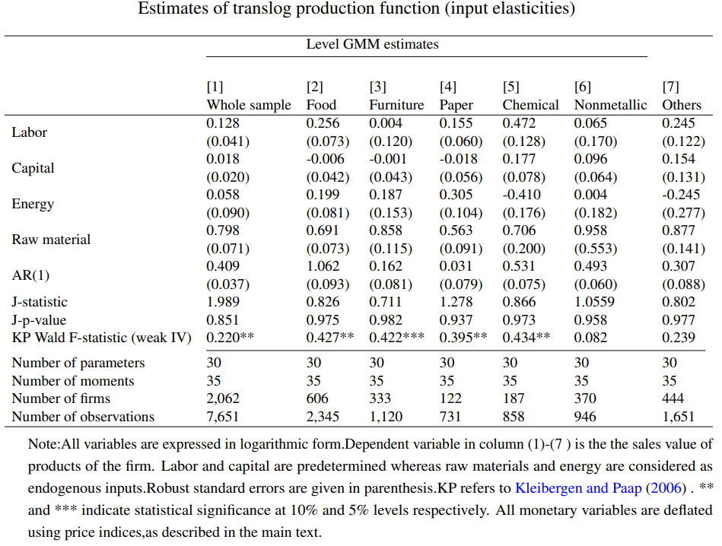

Table B.4
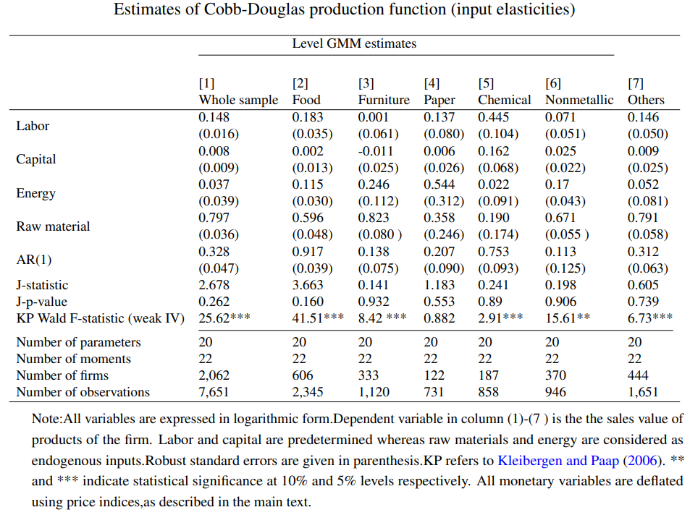

Table B.5
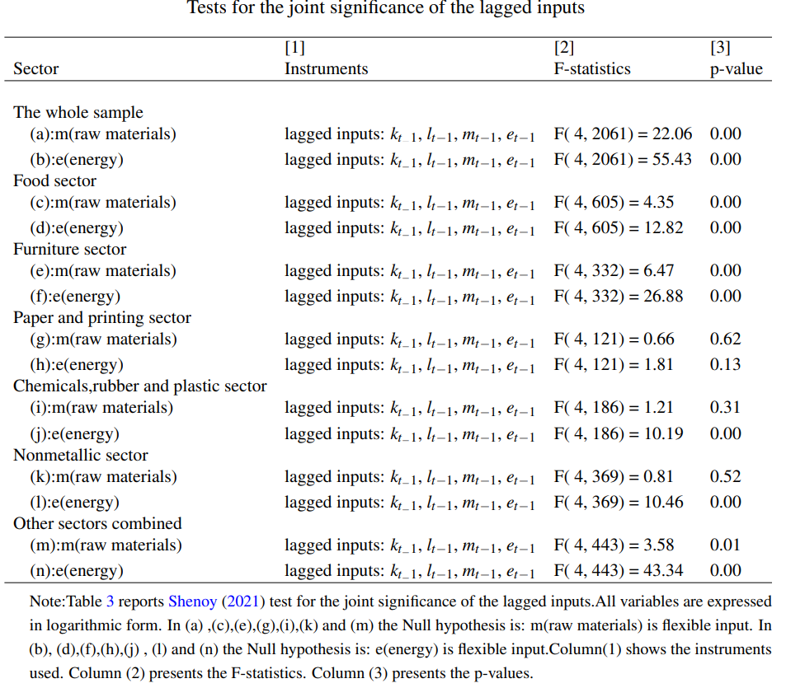

∗ We are grateful for comments from the editor and two anonymous referees. We have benefited a lot from conversations with Steve Bond and Yun Xiao regarding various econometric issues. We are grateful for constructive comments from Dick Durevall on an earlier version of the paper. We thank the Central Statistical Agency (CSA) of Ethiopia for providing access to establishment level data used in this paper. We also thank, respectively,Abebe et al. (2018), and International Growth Centre (IGC) in Ethiopia, for providing firm-level panel datasets for (1996-2913) and (2013-2017). These datasets were merged by a team of researchers based at the Ethiopian Development Research Institute (EDRI) and Oxford University, and we gratefully acknowledge the efforts and help from these individuals. Hailegebriel Yigezu gratefully acknowledges financial support for his PhD study from the Swedish International Development Cooperation Agency (SIDA).
† Corresponding author: mans.soderbom@economics.gu.se
Kebede & Heshmati (2020) used panel data to document a positive and significant association between energy use and labor productivity in the Ethiopian manufacturing sector, and Hassen et al. (2018) analyzed the adoption of energy-efficient practices among larger firms in Ethiopia. Several other studies have examined various aspects of productivity in Ethiopian manufacturing firms, such as enterprise clustering, pricing, agglomeration, productivity(Siba et al., 2012, 2020), productivity and efficiency determinants(Abegaz, 2013; Hailu & Tanaka, 2015; Tekleselassie et al., 2018), tariffs and firm performance(Bigsten et al., 2016), exporting and firm performance (Bigsten & Gebreeyesus, 2009), and the effects of importing on firm productivity (Abreha, 2019).
We use a revenue production function rather than a gross-output specification because our data do not include input price information.
Shenoy (2021) uses a similar theoretical framework for his analysis of constraints in input markets.
Quasi-differencing involves subtracting $ρr_{i,t-1}$ from both sides of (7) and substituting $ρr_{i,t-1}=$ $ρlog⁡F\left(L_{i,t-1},K_{i,t-1},E_{i,t-1},M_{i,t-1}\right)+ρa_{i,t-1}$ on the right-hand side of the equation.
The elasticities for energy and raw materials are $ξ_{E,it}=α_{e}+2α_{ee}e_{it}+α_{le}l_{it}+α_{ke}k_{it}+α_{em}m_{it}$and $ξ_{M,it}=α_{m}+2α_{mm}m_{it}+α_{lm}l_{it}+α_{km}k_{it}+α_{em}e_{it},$ respectively. Mean-centering the inputs implies that the sample-averages of the elasticities are given by $α_{e}$and $α_{m}$, respectively, which facilitates interpretation.
It may seem questionable to treat energy and raw materials analogously to labor and capital in a production function framework. For instance, one could reasonably argue that substitution possibilities between raw materials and labor are very limited. It is doubtful whether a translog specification can fully capture such mechanisms. We nevertheless follow this approach because it provides a feasible and tractable way to estimate elasticities and implement our alignment test.
Some recent studies in the production literature have highlighted weak instruments problems, e.g. de Roux et al. (2024) and Shenoy (2021).
- We constructed this panel from firm-level data covering the periods 1996-2013 and 2013-2017. The data sets were merged by a research team from the Ethiopian Development Research Institute (EDRI), now known as the Policy Study Institute (PSI), and Oxford University. To address issues posed by the introduction of new establishment identification numbers introduced by the CSA after 2011, the team used a combination of firm International Standard Industry Classification (ISIC) codes, establishment numbers, taxpayer identification numbers, phone numbers, and establishment names to match firms over time. For more details, see Online Appendix A. See also Diao et al. (2021).
- The 15 sectors that are distinguished in the raw data are: food, beverages, tobacco, textiles, apparel, leather, footwear, wood, furniture, paper and printing, chemicals, rubber and plastics, nonmetallic, fabricated metal, and other industries combined.
The Online Appendix is available here: www.xxxxxxxxxxxx.com [correct link to be added following decision to accept paper for publication].
We do not have data on labor hours contributed to production.
Estimates by industry are presented in the Online Appendix.
The full set of instruments is thus as follows: $y_{t-2},l_{t},l_{t-1},k_{t},k_{t-1},e_{t-1},m_{t-1},l_{t}^{2},l_{t-1}^{2},k_{t}^{2},k_{t-1}^{2},e_{t-1}^{2},m_{t-1}^{2},l_{t}k_{t},l_{t-1}k_{t-1},l_{t}e_{t-1},k_{t}e_{t-1},k_{t}m_{t-1},e_{t-1}m_{t-1}$, plus a full set of year dummies.

